

Link Local address

Link local addresses are mandatory in IPv6 (internet protocol version six) while loop back addresses are mandatory. It can be used within the context of single layer two domains Router divides layer two domain. Packets sourced or destined to link local address are not forwarded out of layer two domain by the routers.

These addresses are useful for establishing the communication across the link in the absence of globally routable. Technically link local addresses are within the prefix of **FE80:: /10 .** On cisco IOS , an IPV6 enabled interface must be assigned with link local address . In Cisco routers Link local addresses can be manually assigned or they can be created by the Routers itself by using a technique known as EUI(extended unique identifier) .

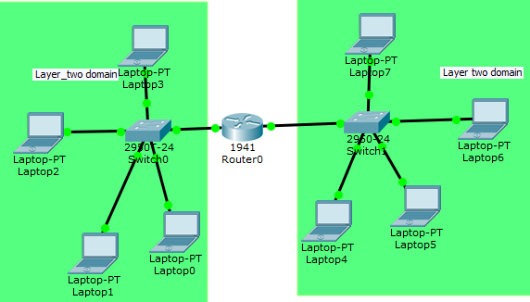

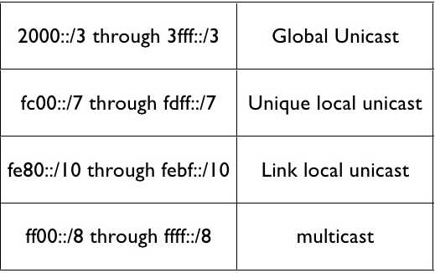

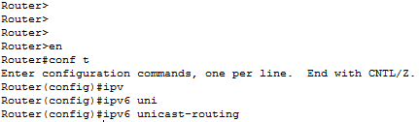IPV6 feature is not installed by default on cisco router in order to enable the router to support IPv6 use the command “ipv6 unicast-routing” in router CLI(command line linterface).

And then in order to assign IPv6 address to interface follow use these simple steps

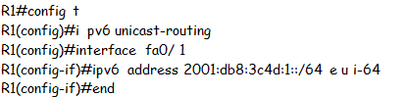

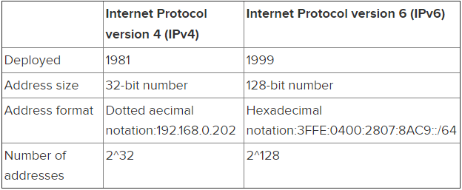

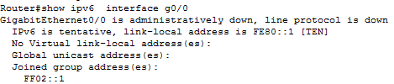The link local address created by using this Technique can be viewed by using “show Interface fa0/1 ipv6 address”. Note after interface you have to put the respective interface number.

EUI (extended unique identifier) means link local address will be automatically generated or if you want to assign link local addresses from the range of

Or if you want to manually assign link-local address to all devices inside your network

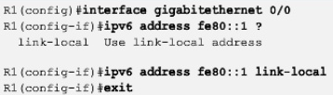

**DNS (domain name system)**

Domain name system is used to convert Domain-name into IP address like in IPv4 (internet protocol version four) we usually use the public DNS of Google (8.8.8.8).Make sure you able to ping this address else DNS problem will occur . Likewise in IPV6 public DNS of Google **is 2001:4860:4860::8888.**

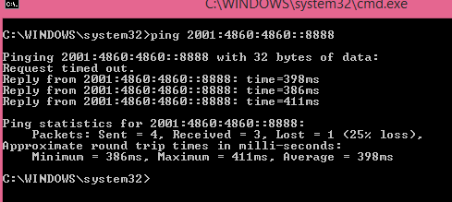

**DHCP (Dynamic host configuration protocol) services in IPv6**

Same like IPv4(internet protocol version four) in IPv6 enabled network we have to use the DHCP service to automatically assign Ipv6 addresses to all host connected in LAN.

But unlike IPV4 in IPV6 the DHCPV6 supports two different methods

* Stateful configuration
* Stateless configuration( also known as Stateless auto configuration SLACC)

The stateful version of DHCPV6 is pretty much the same as for IPv4. The DHCP enabled server or router will assign IPV6 address to all clients and will keep track of binding. If you are using cisco router as DHCP server this Binding can be seen by using the command “show ip dhcp binding”

DHCP (dynamic host configuration) enabled routers or server assigns IP(internet protocol ) address for a specific period and after that period client has to request again to DHCP router to assign IP address.

Stateless Auto configuration is an important feature offered by IPV6 protocol. It allows various devices attached to IPv6 network to connect to internet using the **state less auto configuration** without having need of DHCP (dynamic host configuration protocol).

Quick Quiz

1. How many bits are in IPv6 address?
2. 128
3. 64
4. 32
5. 48

**Answer A**: in IPV6 we have 128 bits like (2001:0DB8:0FF2E: ABCD: 1).

1. What operating System currently support IPV6(internet protocol version six)
2. Linux
3. BSD
4. MAC
5. All of above

**Answer: D**

1. Which feature of IPv6 allows devices to assign IPv6 address to them selves
2. Stateless auto configuration
3. Stateful auto configuration
4. NDP( network discovery protocol)
5. None of the above

**Answer: A**

1. Which these of two statements are true about IPV6 (internet protocol version six) presentation.
2. The first 64 bits represent the dynamically created interface ID
3. A single interface can be assigned with multiple IPV6 addresses
4. Leading Zeros are eliminated
5. All of the above

**Answer: C**

1. What us the total number of IP addresses that can be supported by IPV6
2. 2^32
3. 2^48
4. 2^128
5. 2^64

**Answer: C**